Periodontal Concepts
300 SE 120th Ave, Ste. 500; Vancouver, WA 98683
Office (360) 254-8151
Emergency: Dr. Munib Derhalli (360)241-3664
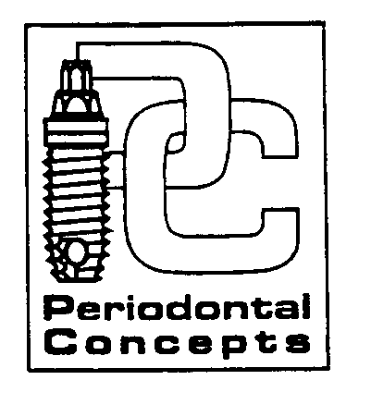

INSTRUCTIONS FOLLOWING PERIODONTAL SURGERY
Sinus Augmentation (Bone Grafting)
PLEASE READ AND FOLLOW THESE GUIDELINES FOR OPTIMAL COMFORT AND A SUCCESSFUL RESULT

1. BLEEDING: Expect minor oozing for up to 24 hrs. after surgery. If bleeding continues apply pressure with a wet gauze/napkin for approximately 20-30 min.; but if heavy bleeding continues, contact Dr. Derhalli immediately.

2. SWELLING: Some swelling is NORMAL after surgery. Place an ice pack adjacent to the surgical site over the next 36 hours alternating the pack 15 minutes on and 15 minutes off (During waking hours). If swelling continues use a warm pack after 36 hours up to 3 days.

3. MEDICATIONS: Take your prescriptions as instructed. Please Do Not Blow Your Nose or Cough Forcefully; use an over the counter Antihistamine (such as Sudafed). Do not drink alcoholic beverages or take other medicine without checking with your doctor first. Take medication with FOOD to lower the chance of getting nauseated. If you do become sick, or a rash develops, notify Dr. Derhalli immediately.

4. FLUIDS: Drink plenty of fluids for the next few days. AVOID USING A STRAW for the first 48 hours after surgery. Suction forces in the mouth encourage bleeding.

5. DIET: Eat whatever feels comfortable, such as soups and nourishing soft foods, for a few days following surgery. (Example- instant breakfast foods, ensure supplement drink, yogurt, mashed potatoes, etc.) Please avoid chewing on the side of the surgical procedure. Avoid hard, crunchy, or small seed foods that could traumatize and injure the surgical site. Do not chew GUM as it may stick to the sutures.

6. ACTIVITY: Rest is essential for successful recovery. Please rest the day of your procedure and reduce your activities for the next few days. Avoid running or strenuous activity for 3-4 days.

7. MOUTHSOAKS: Gently rinse your mouth with warm salt water after each meal to keep the area clean. Use the prescribed rinse morning and night, rinsing for 30 seconds (ie: Periogard).

8. BRUSHING: A clean mouth heals faster! Exercise caution not to injure the surgical site. Avoid brushing and flossing the surgical site until specified by Dr. Derhalli

9. AVOID: No smoking (or tobacco products), alcoholic drinks, peroxide or commercial mouthrinses following surgery.

10. SUTURES: Sutures will/will not dissolve – However an appointment will be made for any residual sutures to be removed.

If you have any questions regarding your surgical procedure,
please, do not hesitate to contact our office.

